**Assignment # 2**

**Title:**

Statistics and trends for GDP Growth

**Name:**

Samreen Safdar

**Abstract:**

This study shows 4 countries select for the interrelation of Gross Domestic Product (GDP) Growth and Natural Resource Depletion. The year used for this investigation is 1980-2015. Usually, the country measures its economy size with the help of Gross Domestic Product (GDP) Growth. Nowadays, Natural Resources are consumed faster as compared to the past century. In this usage rate, the recovery of National Resources is cannot recover. The depletion is associated with fuel usage and water consumption.

**Github link:**

[https://github.com/umairmalik00746/AppliedData-Science2.git](.ipynb_checkpoints)

**World bank:**

<https://data.worldbank.org/topic/climate-change>

GDP Growth:

This table shows the Gross Domestic Product GDP Growth from 1980-2015 in United Kingdom, Australia, South Africa and New Zealand.

|  |  |  |  |  |
| --- | --- | --- | --- | --- |
| **Country** | **United Kingdom** | **Australia** | **South Africa** | **New Zealand** |
| 1980 | 2.031368 | 3.035399 | 6.620583 | 1.28393 |
| 1985 | 4.147415 | 5.252115 | 1.211541 | 1.615423 |
| 1990 | 0.733756 | 3.573507 | 0.31776 | 0.152973 |
| 1995 | 2.53167 | 3.833831 | 3.1 | 4.722465 |
| 2000 | 3.672369 | 3.912428 | 4.2 | 2.905141 |
| 2005 | 2.59328 | 3.160338 | 5.277052 | 3.320717 |
| 2010 | 2.131438 | 2.172337 | 3.039733 | 1.523878 |
| 2015 | 2.622597 | 2.172205 | 1.321862 | 3.744332 |

**Table: GDP Growth 1980-2015**

In this study, the line graph shows that GDP Growth is maintained most of the time between a 1-5 % ratio. This means the GDP Growth of these countries (United Kingdom, Australia, South Africa, and New Zealand) are stable. In the Bar graph, we see that South Africa's GDP is 6% in 1980 than it suddenly drops to 1% but after that GDP crisis, Australia managed to maintain GDP growth again. The heatmap graph shows mostly the GDP growth of these countries is 2 and 4 %.

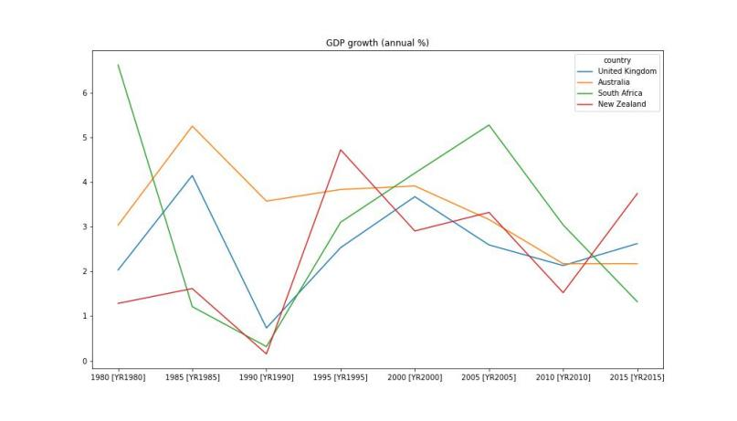

**GDP Growth Line Graph**

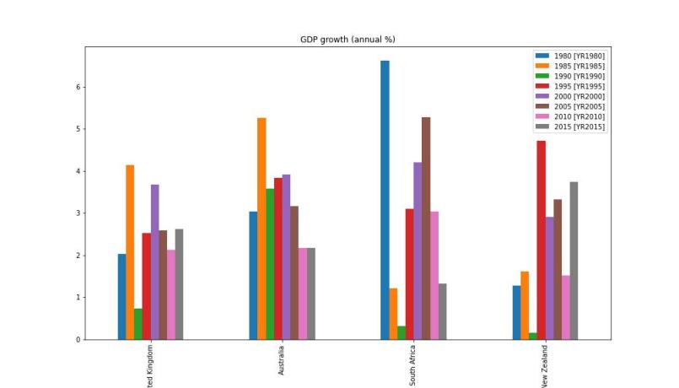

**GDP Growth Bar Graph**

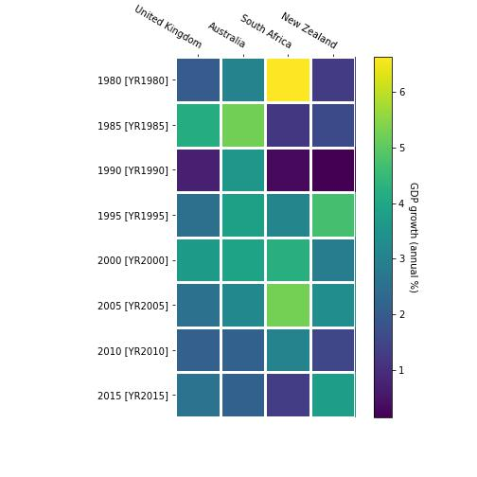

**GDP Growth Heatmap Graph**

This table shows the Natural Resource Depletion from 1980-2015 in United Kingdom, Australia, South Africa and New Zealand.

|  |  |  |  |  |
| --- | --- | --- | --- | --- |
| **Country** | **United Kingdom** | **Australia** | **South Africa** | **New Zealand** |
| 1980 | 1.503493 | 3.393419 | 8.021072 | 0.232161 |
| 1985 | 1.993058 | 2.810482 | 5.832153 | 0.519375 |
| 1990 | 0.865604 | 2.034459 | 2.634423 | 0.697761 |
| 1995 | 0.519549 | 1.354007 | 1.514406 | 0.33794 |
| 2000 | 0.89065 | 1.858572 | 1.217264 | 0.852663 |
| 2005 | 0.745885 | 2.049529 | 1.936865 | 0.427238 |
| 2010 | 0.87796 | 2.720819 | 3.321567 | 1.047099 |
| 2015 | 0.289809 | 1.467298 | 1.039391 | 0.573418 |

**Table: Natural Resource Depletion 1980-2015**

The line Graph shows that Natural Resource Depletion is decreased by year by year. In 1980 the South Africa Natural Resource Depletion (% of GNI) decreased by 8 % which is too big a figure.

Also, the country's Natural Resource Depletion decreased by 1 to 4 percent every year which is an alarming situation for the world. If natural resources decrease year by year, then it's hard to recover in the future.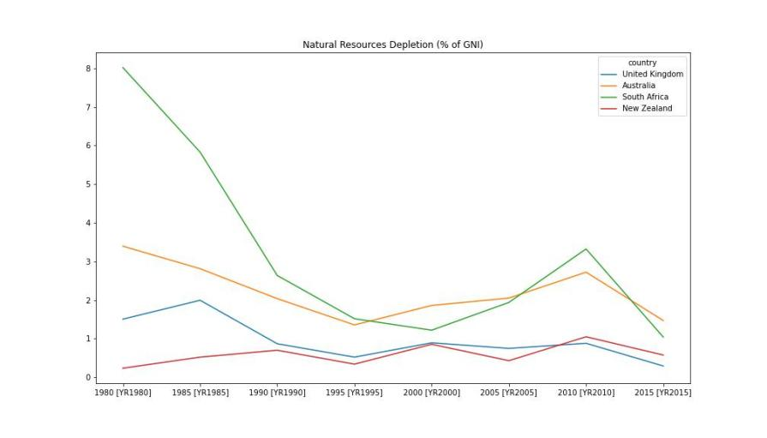

**Natural Resource Depletion Line Graph**

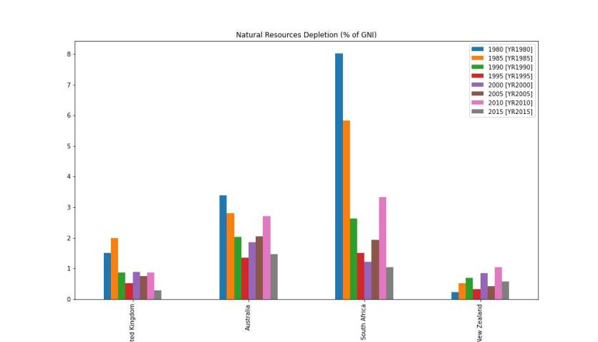

Natural Resource Depletion Bar Graph

The Bar graph shows that South Africa country natural resources decrease fast as compared to other countries. They need to decrease the Natural resources Depletion because if they used resources more than its hard to recover the water usage, fuel consumption, and trees.

